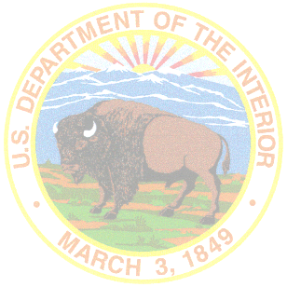***Tribal/Interior Budget Council***

***Education Subcommittee***

***Agenda***

**November 18, 2024**

**1:00 p.m. – 4:30 p.m.**

**Tribal Subcommittee Co-Chairs:**

Buster Atteberry, Karuk Tribe

Juana Majel Dixon, Pauma-Yuima Band of Luiseño Indians

**Federal Subcommittee Co-Chair:**

Tony Dearman, Director, BIE

Sharon Pinto, Deputy Bureau Director, BIE

* Welcome and Opening Remarks
* Voting Member Roll Call
* Updates
  + Report from BIE – Tony Dearman, Director; Sharon Pinto, Deputy Director
  + NIEA Update – Julia Wakeford, Policy Director, NIEA
  + AIHEC Update- Ahniwake Rose, President & CEO, AIHEC
* General Tribal Leader Discussion
  + Methodology for BIE Cost Estimates
    - Tribal Grant Support Costs
    - Johnson O’Malley Assistance Grants (Revise Cost Estimates)
      * National Johnson-O'Malley Association (invited)
    - Tribal Colleges and Universities (TCU) Allocation and Funding Overview (BIE)
      * Tribal Colleges Allocation and Funding Overview-BIE
      * AIHEC (invited)
    - Tribal Colleges and Universities (TCU) Facilities, Improvement, and Repair Allocation and Funding Overview (BIE)
    - Education Construction (Revise/Update Cost Estimates)
* Policy, Legislative, and Programmatic Ideas, Questions, Concerns
* Recommendations for BIE Service Delivery, Implementation, Process Improvement
  + Data Metrics - What is used and how accurate is it?
* Summary of Action Items for Report Out
* March Agenda Recommendations
* Adjourn